17906 – ONBOARDING: New VEO Admin Menu Option

LINK: [url](https://dev.azure.com/BuildOnTechnologies/VeoDesignStudio/_workitems/edit/17906)

# Criteria:

1. Create a new menu option in VeoAdmin under Reports called Tile Patterns 2
2. Clicking the new menu option should route the user to a new page named Tile Pattern Reports 2

# Changes:

## Criteria 1

Menu now contains a new menu option Reports\Tile Patterns 2  
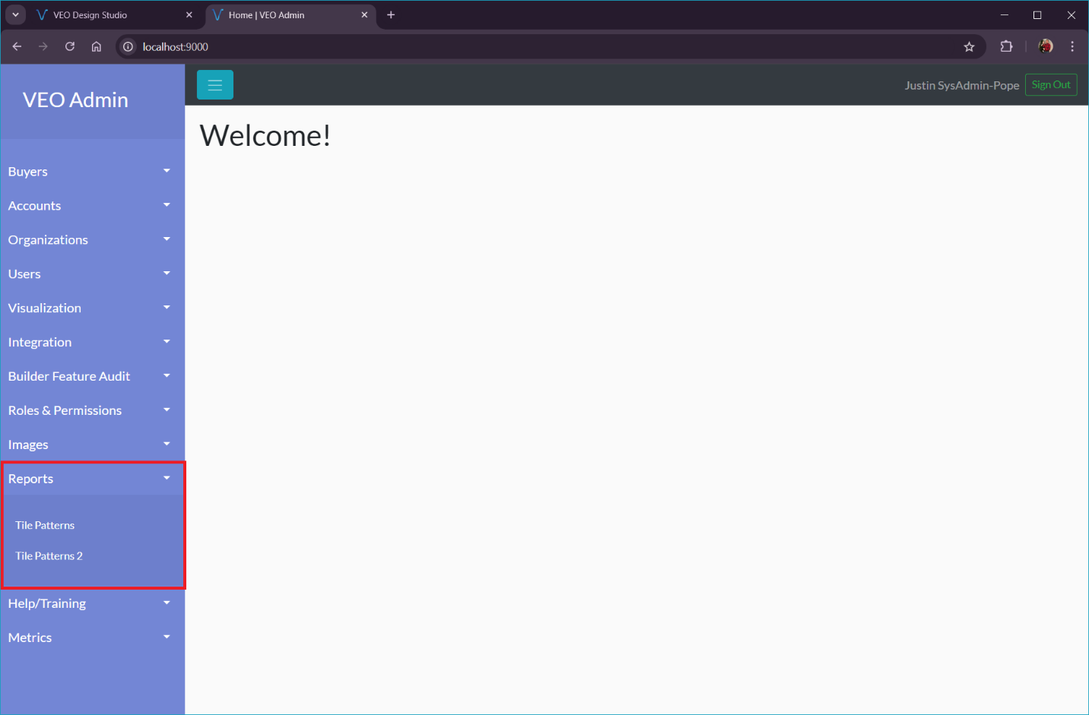

## Criteria 2

Clicking the menu option opens up Tile Pattern Reports 2  
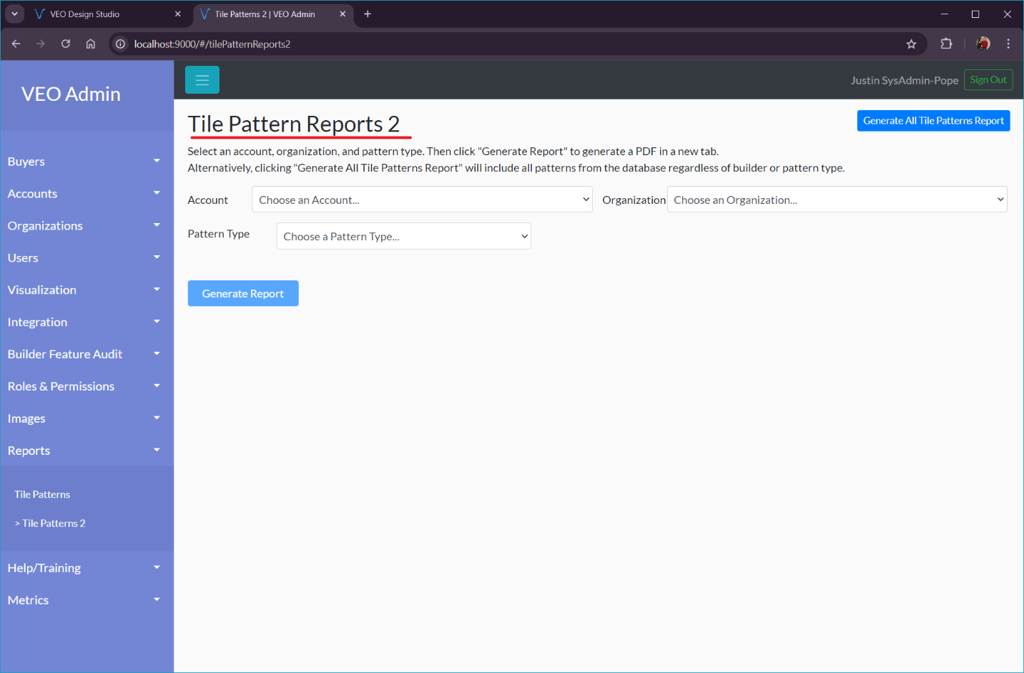

## Code

The following notable code changes.

### App.ts

Line 79 – added the new route to the routes  
Line 114 – extended VeoAdminRouteSettings with property params

### tilePatternReports.ts

To accommodate changing the Title I have modified the ‘component’ by adding two methods to one see the route settings coming in to configure the title and two modify the activation strategy (lines